
Green Dragon Judo Club


Welcome

Thank you for coming to our club.

Please read this important information to help all of us to have an enjoyable and safe experience.

Fees: as published. 10-12 week Terms in advance. Normally reviewed each Sept at the AGM.
This is a non-profit making club. The Sensei’s give all their time for free. All funds go to hall hire,
equipment, insurance, CRB checks, first aid and coaching courses and other training materials.
Licence Fees: due annually, which covers insurance, and UK association membership. We expect Licences to
be applied for within 4 weeks, preferably on the First Wednesday of each month, to reduce our administration costs. This also covers their insurance. Bring your books every week for inspection.
Collection: The sports facility is used by the general public and the car park area is very busy. For this
reason we require ALL children to be collected from the hall. Important information is also given at the
end of the sessions. It would be appreciated if you could leave the building quietly.
Toilet Breaks: Unless an emergency, or via prior arrangement, requests for toilet breaks are normally denied.
Please make sure your child goes before their session starts. Toilet breaks can be disruptive, requires an escort and they may miss an important technique or safety note.
Health: * Hair must be tied up using soft bands,(No baubles). No nail varnish, jewellery, studs.
* Girls are required to wear a suitable T-shirt/vest under their Judo suit.
* Clean hands and feet, including short nails. Socks only worn to cover medical conditions!
* Children must not leave the mat area without gaining permission from the Sensei first.
* Shoes to be worn to the edge of the mat and then slipped off. No bare feet on the floor.
This avoids glass, staples and gum getting onto the children’s feet and keeps the dirt off the mat.
Judo Suits: Judo Suits should be clean and kept in good repair. I do have access to some spares which you may
borrow, (please request in advance), but please see Sensei Mick to purchase your own within a few weeks. We can get them well below shop prices. Donations towards the cleaning costs of the suits borrowed, and any donations of old suits, are very much appreciated. This will help replenish and refresh my spares box.
Spectators: All spectators welcome but please keep the noise down as many whispers can become a distraction
in a hall with bad acoustics. If you wish to talk to a Sensei about anything at all, please do not hesitate to do this before or after the lesson, send us an email, or leave a note when signing in.
Website: www.dojudo.co.uk. (Comments and suggestions always welcome)
On the Syllabus tab, please select “Dojo Rules and Etiquette”. This section includes some standard etiquette, behaviour and basic Health and Hygiene rules.
Please review/print their relevant Syllabus as this will help with assessments and goal setting. The
students have the opportunity to be graded at least twice a year , for a small fee, with practical and
theory tests. Certificates, tabs and belts are awarded for their endeavours.
The News and Events Calendar pages are regularly updated with important dates and information.

Fun: It is most important we all enjoy the sessions. Students, Parents and Instructors alike.

For further information , please contact:-

Mick Williams on 01959 540439 or email Mick@DoJuDo.co.uk

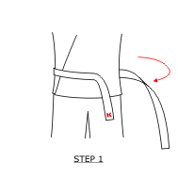 | Start by holding the logo end of the belt a couple of inches longer than the length you want the belt to be when it is tied. Wrap the other end of the belt around your waist.
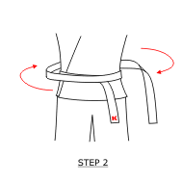 | Continue around your waist a second time, while maintaining the position of the logo end of the belt.  Alternative method: If you put the half-way point of the belt under the naval, and wrap both ends around the back and return to the front, you get to a similar starting point.(Quicker & easier, but you get a small twist at the back)
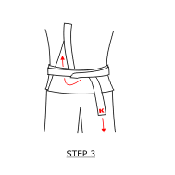 | Tuck the end of the belt under both layers and up. Pull both ends straight up and down to tighten the knot.
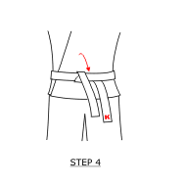 | Fold the belt down.
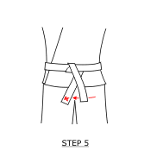 | Tuck the logo end of the belt under the other end.
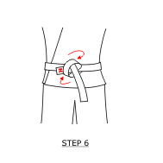 | Loop the logo end of the belt around the other end and through the knot.
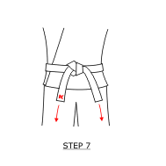 | Pull to tighten the knot. If done properly, both ends will be the same length, pointing down. The above knot can be quickly undone in emergencies, or in competition, when you need 30 seconds rest!!  A Variation of this, called the French Knot, which guarantees to stay done up, can be demonstrated by Sensei Mick. For New belts, Not competition!!

